Kick-off meeting minutes

1.1 Internal Communication and Coordination

January 30, 2024

Content
Attendants ……………………………………………………………………………………2
Agenda ……………………………………………………………………………………….3
Minutes
Discussion and formation of the main work packages of the project……………………………………………………………………………..................3

ATTENDANTS
No. | Partner No. | Organisation | Full name | Role
1 | P9 | KarUK | Galiya Gimranova | Manager
2 | P9 | KarUK | Oxana Bezler | Manager
3 | P9 | KarUK | Karina Nevmatullina | Teacher/Researcher
4 | P9 | KarUK | Yevgeniya Puntus | Teacher/Researcher
5 | P9 | KarUK | Svetlana Glazunova | Administrative
6 | P9 | KarUK | Zariya Aitova | Administrative

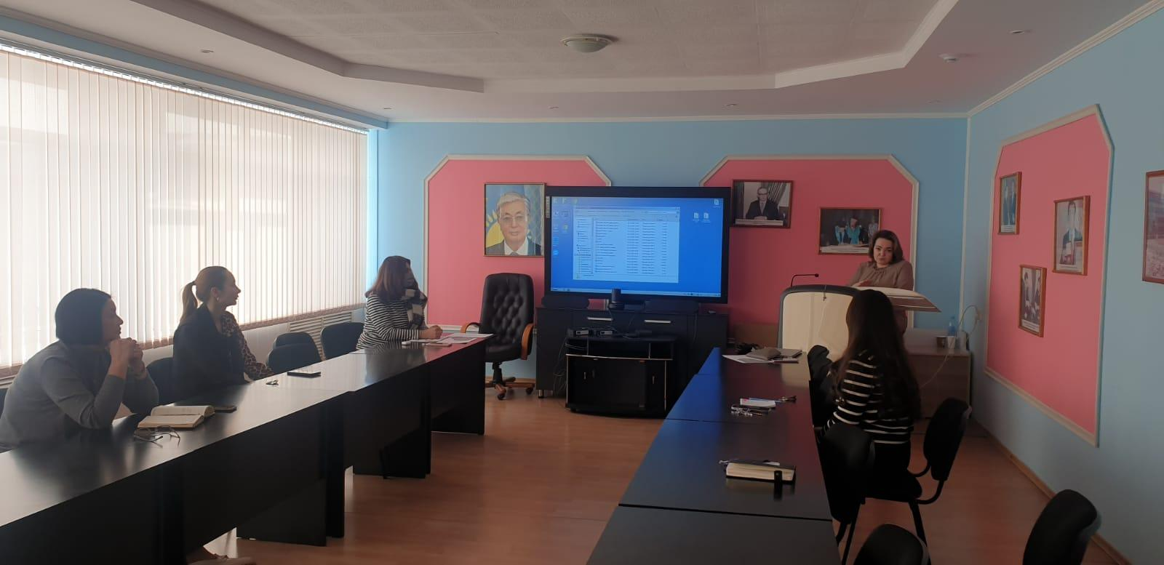

Agenda
- Discussion of the division of responsibilities
- Formation of work documents for working packages of the project

Minutes
Internal communication and coordination of the project working group
The Working Group distributed responsibilities in the areas of the project's activities, studied the work packages, the necessary documentation and the schedule for its provision.
Aims of the project:
- To introduce and integrate the topics of Circular Economy and Sustainable Development into the educational programs of partner countries.
- To accelerate the transition to more circularity and foster the implementation of Sustainability Goals and Green Deal actions.
The project was developed with the participation of Karaganda University of Kazpotrebsoyuz and partners based on a preliminary analysis of the needs of the participating regions.
KarU of Kazpotrebsoyuz is responsible for the working package 7 – Pilot. The aim of WP7 is to develop innovative, interdisciplinary modules in Circular Economy for the existing curricula in bachelor, Master levels and for life-long learning.
The project's working group will also take an active part in the working package 9 – Impact and dissemination.

